Examples of an AI

1. Tesla Autopilot

The Tesla Autopilot is an advanced assisted driving program. It offers features like Autosteer, Autopark and Traffic-Aware Cruise Control.

* The Autopilot is by any means way safer than human-operated vehicles, since it comunicates with all the environment around the car itself and gets and processes information with every possible outcome of the situation, being ready for the worst. This is something that no human can possibly achieve in a dynamic environment, like the road.
* Another cool feature (or technology if I may say so) is that all the Teslas communicate between each other and are updating and improving the company's database of the roads every second they are out on the road. This is what makes the autonomous cars the safest ones – in case all the cars are without drivers, this will kind of remove any risks of road accidents, but we are looking of this happening in the distant future.
* The company intents to offer full self-driving in the future. That may reduce accidents caused by driver's fatigue from longer driving. But for now, the Autopilot needs to be supervised by an active driver.

Some drawbacks (I name them drawbacks, since they are not things I personally dislike, but more to the side of not being perfected yet... What is there to dislike about autopilot ??)

* Even though the Autopilot is safe, it has problems during some sharp turns, due to the limited technology and not enough tests being ran yet.
* Another problem is the lack of availability of the Autopilot. In most of the countries (other than USA, The Netherlands, Germany, Japan etc.) the Autopilot is still not available on the market, due to the insufficient Teslas on the roads there.

2.Google Map’s suggestions for places you might want to visit.

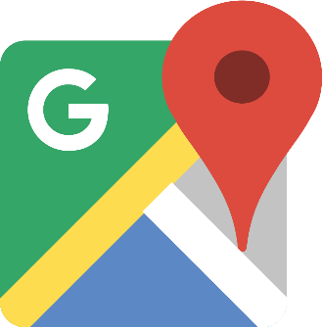

* Based on what places (like restaurant, bars, cafes, museums and so on) you visit in your daily life, Google suggests you places you haven’t visited but thinks are suitable for your taste. The AI does that by studying all the information it collects about you (including your location, and that is the reason some people think that this is too much of a privacy invasion).
* This is a useful feature because it lets you diverse your knowledge of the local sites to spend some enjoyable time.
* It even has information about their most crowded hours.
* Sometimes it even suggests you different events that you might not have heard of.

What I dislike about it is that it collects way too much data about your daily activities and routines. This information might be used by hackers in case of a breach for bad purposes. This is kind of a general problem for most of the nowadays technologies and security must be tightened.